**Hotel Management System**

**Low Level Design (LLD)**

**Done by : Group – UMA BHARTI**

1. **Introduction :**

The hotel management system is the system which is going to be implemented for hotel which will automate the major operations of the hotel. There are different modules present in the system such as Room reservation module, Room module, Inventory control module, etc. Reservation module will keep track on room reservation and availability. Room module is for manage all room types and room services. The Inventory Control module will keep track in all inventories of the hotel and guest details will handled by guest management.

There are three end users of the system as : Owner, Manager and Receptionist.

Owner will be having access to all system functionalities without any restriction. Manager will be having all rights of the system functionalities but with limited restrictions.

Receptionist can only access to the Reservation management section.

1. **Document Purpose :**

The document will provide the whole idea about the system. This will also provide a detailed description of requirements and system functionalities of hotel management system. There is a brief description about the working of newly introduced system. This document will allow for complete understanding of the functionality of proposed system.

1. **Intended Audience :**

This document is intended as a references for the following roles who are involved in the Hotel Management System.

|  |  |
| --- | --- |
| Role | Nature of Engagement in Hotel Management System |
| Owner | Hotel owner has rights of monitoring and authorization of all the tasks handled by the system. As the main authorized person of the hotel, Owner gets the ability to manage all the departments including all the reports generated throughout the day. He can also set the room rates.  Assigning roles to the staff is also one of the important responsibilities. |
| Manager | Manager has duty of managing top to the bottom level workforce.  His responsibility to keeping the hotel running and live , he has to be aware of each and every action taken. The reason of using manager is to reduce the workload of owner. Manger have all the privileges and rights like owner except things regarding payment handling and managing departments. |
| Receptionist | Receptionist has the rights to access reservation system. Receptionist can search rooms, make reservation, issue bill and add guest details. |

1. **Project Background and Objective(s)**

**4.1) Project Background :**

Hotel Management System leads to perform Management of Hotel where receptionist and Manager will take care of customer details and hotel Operations. The owner will be the authorized person who has all the privileges and rights to handle the day to day operations.

**4.2) Project Objective :**

The objective of the automated Hotel Management System is to simplify the day to day process of the hotel. The system will be able to handled many services to take care of all customers in a quick manner. The main purpose of this system is to overcome those drawbacks which were present in manual system. In manual system, large amount of file handling happening at the hotel which is not easy to maintain. Safety, easiness of using and most importantly the efficiency of information retrieval is some benefits of this system.

**UML Diagrams**

1. **Database Diagram**

**Activity Diagram**

**Receptionist**

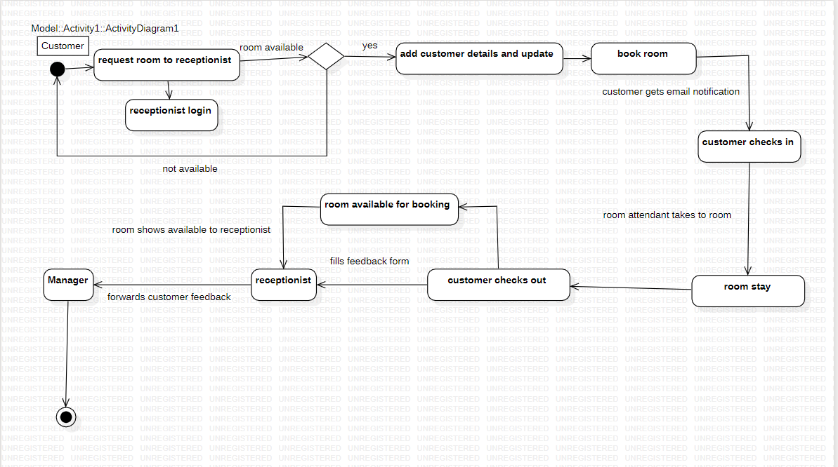

**Owner**

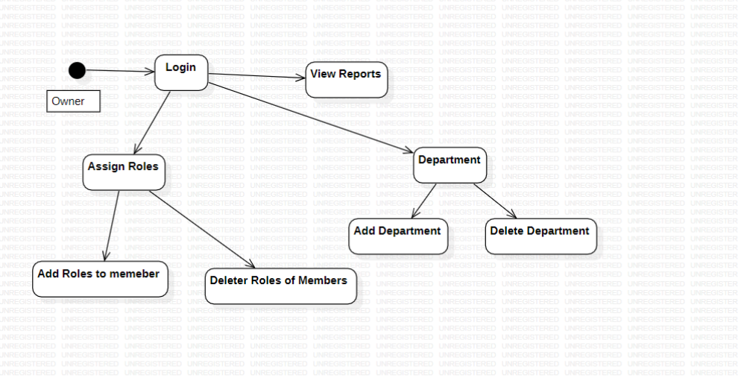

**Manager**

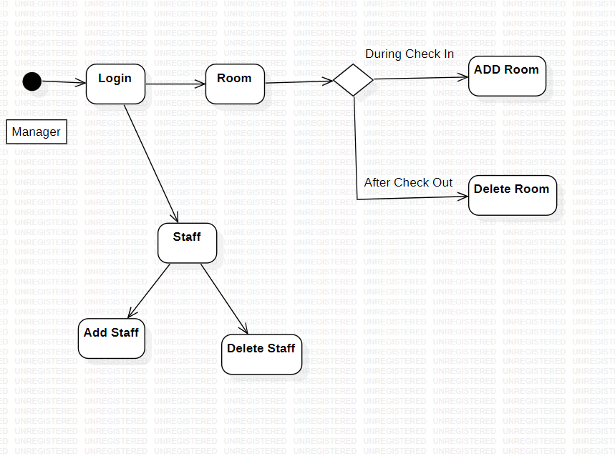

**Use-Case Diagram :**

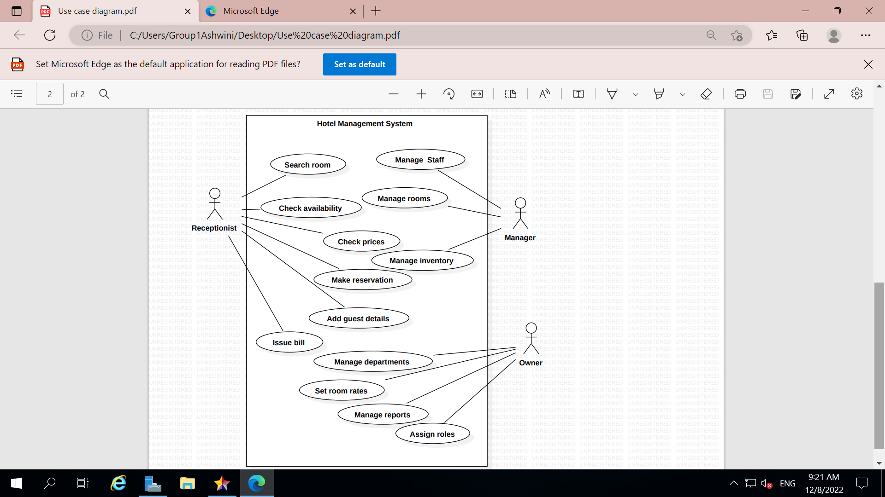

**Sequence Diagram**

